**PRESS RELEASE**

**COMMUNICATIONS AND MEDIA TEAM OF THE 2023 ASEAN SUMMIT**

**No. 65/SP/TKM-ASEAN2023/ENG/5/2023**

**42nd ASEAN Summit Promotes Labuan Bajo as MICE Destination**

**West Manggarai, 10 May 2023** – The 42nd ASEAN Summit 2023 leveled up Labuan Bajo as a world-class Meeting, Incentive, Conference, and Exhibition (MICE) and tourism destination.

Indonesia’s Tourism and Creative Economy Minister Sandiaga Salahuddin Uno said the finding during a press conference at the Media Center of the 42nd ASEAN Summit 2023 at the Bintang Flores Hotel, Labuan Bajo, West Manggarai Regency, East Nusa Tenggara (NTT), Wednesday, 10 May.

"Labuan Bajo is ready to hold world-class events, for instance, the ASEAN Summit. We will participate in future bidding to make Labuan Bajo a world-class MICE destination," said Sandiaga Uno.

He also revealed that the Ministry would bring more national and international class events to Labuan Bajo.

"We will ensure that events throughout the year create 4.4 million new jobs by 2024," he said.

He said that Labuan Bajo is a unique and remarkable destination. Therefore, it is included as one of the Super Priority Tourism Destinations.

"Here, the land accommodations are not only hotels and resorts, but also homestays, sarhunta (tourism residential facilities), and tourist villages. Sea accommodation such as Live on Board (LOB), a part of the tourist attractions, is also available. That is what we need to publicize and inform tourists that they have options for accommodation," he said.

Sandiaga saw positive trends in the tourism sector and the creative economy along with international conference organizations in Southeast Asia. Tourist arrivals will increase and help Indonesia to achieve the target of 8.5 million foreign tourist visits in 2023.

"Labuan Bajo has a total of 300.000 to 350.000 foreign tourists visits. Maybe, it will increase by 10 to 20 percent thanks to the 42nd ASEAN Summit 2023," he said.

Sandiaga was accompanied by the Secretary of the Ministry of Tourism and Creative Economy, Ni Wayan Giri Adnyani; Deputy for Resources and Institutions of the Ministry of Tourism and Creative Economy/Baparekraf, Martini Mohamad Paham; Deputy for Tourism Products and Activities Organizer, Ministry of Tourism and Creative Economy/Baparekraf Vincent Jemadu; Head of the Ministry of Preservation/Baparekraf Communication Bureau, I Gusti Ayu Dewi Hendriyani; and the Director of National and International Events for the Ministry of Tourism and Creative Economy/Baparekraf, Dessy Ruhati. (Kemenparekraf/TR/Elvira/WS)

***

For more information, please contact:

**Director General of Public Information and Communications of the Ministry of Communications and Informatics - Usman Kansong (0816785320)**

Get other information at <http://asean2023.id>, <https://infopublik.id/kategori/asean-2023>, and <https://indonesia.go.id/kategori/ragam-asean-2023>

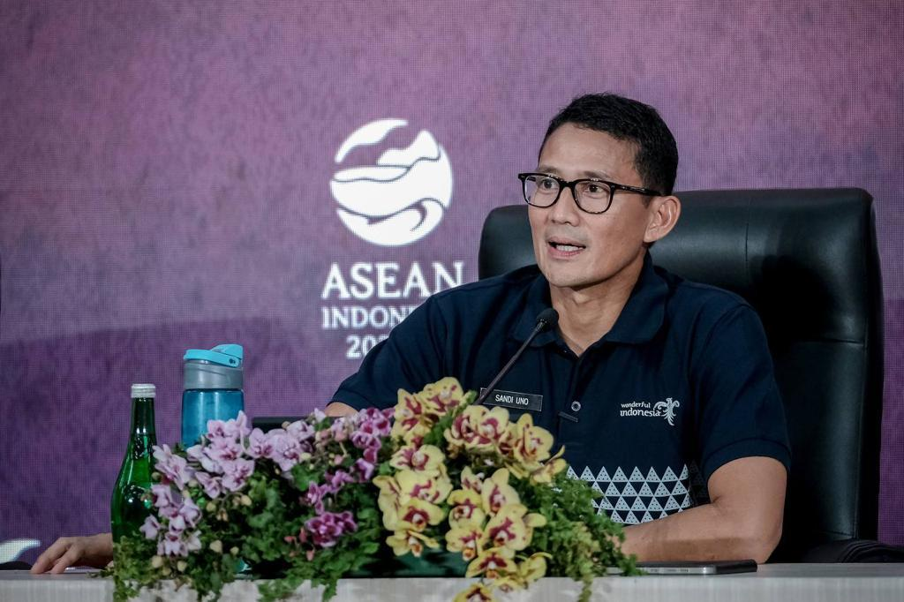

Minister of Tourism and Creative Economy/Head of the Indonesian Tourism and Creative Economy Agency, Sandiaga Salahuddin Uno, in a press conference at the Media Center of the 42nd ASEAN Summit 2023 at the Bintang Flores Hotel, Labuan Bajo, Wednesday, 10 May 2023. The 42nd ASEAN Summit 2023 escalates the readiness of Labuan Bajo as a world-class Meeting, Incentive, Conference, and Exhibition (MICE), not only as a tourism destination. Photo: Public Relations Ministry of Tourism and Creative Economy